**EXPERIMENT 8**

**DATE: 11/02/2020**

**[Modeling UML Use Case Diagrams and Capturing Use Case Scenarios](http://vlabs.iitkgp.ernet.in/se/3/)**

* Use case diagrams
* Identifying Actors
* Use Case
* Association between Actors and Use Cases
* Use Case Relationships
* Include Relationship
* Extend Relationship
* Generalization Relationship

m

**Modelling UML Use Case Diagrams and Capturing Use Case Scenarios**

 A [UML](https://en.wikipedia.org/wiki/Unified_Modeling_Language" \t "_blank) use case diagram is the primary form of system/software requirements for a new software program underdeveloped. Use cases specify the expected behaviour (what), and not the exact method of making it happen (how). Use cases once specified can be denoted both textual and visual representation (i.e. use case diagram). A key concept of use case modelling is that it helps us design a system from the end user's perspective. It is an effective technique for communicating system behaviour in the user's terms by specifying all externally visible system behaviour.

A use case diagram is usually simple. It does not show the detail of the use cases:

* It only summarizes **some of the relationships** between use cases, actors, and systems.
* It does **not show the order** in which steps are performed to achieve the goals of each use case.

**Usecase Diagram for Online voting system Community Page**

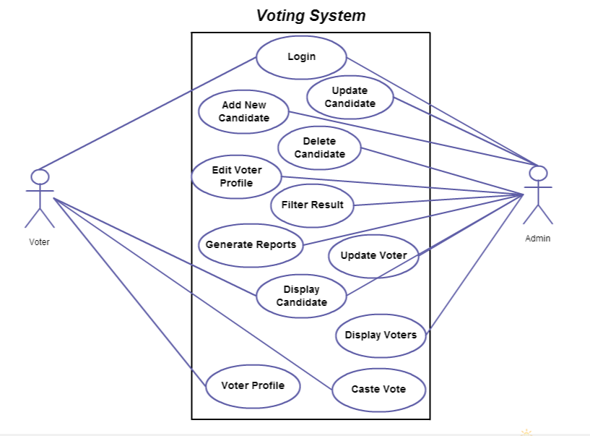

Use case diagrams are typically developed in the early stage of development and people often apply use case modelling for the following purposes:

* Specify the context of a system
* Capture the requirements of a system
* Validate a systems architecture
* Drive implementation and generate test cases
* Developed by analysts together with domain experts

**Identifying Actors**

* Someone interacts with use case (system function).
* Use Case Diagram Notation - ActorNamed by noun.
* Actor plays a role in the business
* Similar to the concept of user, but a user can play different roles
* For example:
  + A prof. can be instructor and also researcher
  + plays 2 roles with two systems
* Actor triggers use case(s).
* Actor has a responsibility toward the system (inputs), and Actor has expectations from the system (outputs).

For a agricultural community based project the actor will be student, farmer and public.

Use Case Diagram Notation - Use Case**Identifying Use Cases**

* System function (process - automated or manual)
* Named by verb + Noun (or Noun Phrase).
* i.e. Do something
* Each Actor must be linked to a use case, while some use cases may not be linked to actors.

For a agricultural community based project the use cases will be Registration, Login, Upload Post, View Post, QnA Section, Chat Section, Log Out.

**Association between Actors and Use Cases**

**Communication Link**

* The participation of an actor in a use case is shown by connecting an actor to a use case by a solid link.
* Actors may be connected to use cases by associations, indicating that the actor and the use case communicate with one another using messages.

**Use Case Relationships**

**Include Relationship**

* When a use case is depicted as using the functionality of another use case, the relationship between the use cases is named as include or uses relationship.
* A use case includes the functionality described in another use case as a part of its business process flow.
* A uses relationship from base use case to child use case indicates that an instance of the base use case will include the behaviour as specified in the child use case.
* An include relationship is depicted with a directed arrow having a dotted line. The tip of arrowhead points to the child use case and the parent use case connected at the base of the arrow.
* The stereotype "<<include>>" identifies the relationship as an include relationship.

Use Case Diagram Notation - Include

**Extend Relationship**

* Indicates that an **"Invalid Password"** use case may include (subject to specified in the extension) the behaviour specified by base use case **"Login Account"**.
* Depict with a directed arrow having a dotted line. The tip of arrowhead points to the base use case and the child use case is connected at the base of the arrow.
* The stereotype "<<extends>>" identifies as an extend relationship

Use Case Diagram Notation - Extend

**Generalization Relationship**

**Generalization**

* A generalization relationship is a parent-child relationship between use cases.
* The child use case is an enhancement of the parent use case.
* Generalization is shown as a directed arrow with a triangle arrowhead.
* The child use case is connected at the base of the arrow. The tip of the arrow is connected to the parent use case.

|  |  |  |  |
| --- | --- | --- | --- |
| **Presentation (4)** | **Documentation (3)** | **Explanation (3)** | **Total (10)** |
|  |  |  |  |

Use Case Diagram Notation - Generalization